

THE S D VIDYA SCHOOL
GRIEVANCE REDRESSAL MECHANISM

OBJECTIVES
- To ensure a fair, impartial and consistent mechanism for redressal of varied issues faced by the stakeholders.
- To uphold the dignity of the School by promoting cordial Student-Student relationship, Student-teacher relationship, teacher-teacher relationship;
- To develop a responsive and accountable attitude among the stakeholders, thereby maintaining a harmonious atmosphere in the School campus;
- To ensure that grievances are resolved promptly, objectively and with sensitivity and in complete confidentiality;
- To ensure that the views of each grievant and respondent are respected and that any party to a grievance is neither discriminated against nor victimized;
- To advise stakeholders to respect the right and dignity of one another, and not to behave in a vindictive manner towards any of them for any reason.

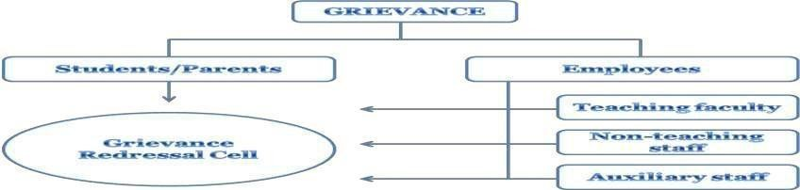
GRIEVANCE REDRESSAL MECHANISM IN RELATION TO THOSE INVOLVED
OTHERS

GRIEVANCES REDRESSAL COMMITTEE
A high-power committee handles the function of remedying of grievances. It is guided by the principles of natural justice while redressing the grievances. The committee will consider only formal grievances, received via email at sdschoolnoida@yahoo.com or principalsdvs@gmail.com or in person, and put its best efforts in order to arrive at a right decision/amicable solution expeditiously.

GRIEVANCE REDRESSAL COMMITTEES
As per guidelines issued vide CBSE’s circular dated 12.09.2017, committee for redress of grievances has been set up with the following members:

REDRESSAL COMMITTEE FOR GRIEVANCES

S. No. | Name of the members | Designation | Sign
1 | Ms. Anu Puri | Principal
2 | Mr. Umaid Iftekhar | Manager
3 | Ms. Neetu Manocha | Teacher
4 | Ms. Aakriti Khosla | Counsellor

FORMAL GRIEVANCE REGISTRATION FORM

(Suggested Form)
Grievant’s Profile

Name: ………………..……………………………………………………………………….
Gender: Male/Female
Status: Student Parent Staff member Other
Admission no of student …………………………………………………….

Dept./Office:………………………………..………………………

Phone:………………………………….…………

Email:…………………………………….………………………………

Grievance Details

Type of Grievance: Academic Related Extension & Extra-curricular Amenities & Maintenance General Administration
Other related issues
…………………………………………………………………….. Date of Occurrence: ………………………………
Have you discussed this issue with your Mentor and/or HoD/ Class Teacher/ Counselor?

Yes No Not applicable Date(s) of discussion: …………………………………….
Mentor’s/HoD’s/ Class Teacher/ Counselor Name:

…………………………….………………………………. Phone:………………………………………….
Note: Must be filed within 5 working Days
Issue of Grievance: (Describe what happened, when and where, how your student experience or employment has been affected, and indicate names of others involved. Attach any supporting documentation.)

………………………………………………………………………………………………………………………..

....……………………………………………………………………………………………………………………

………………………………………………………………………………………………………………………

………………………………………………………………………………………………………………………

………………………………………………………………………………………………………………………

………………………………………………………………………………………………………………………

………………………………………………………………………………………………………………………

………………………………………………………………………………………………………………………

………………………………………………………………………………………………………………………

………………………………………………………………………………………………………………………

………………………………………………………………………………………………………………………

………………………………………………………………………………………………………………………

………………………………………………………………………………………………………………………

………………………………………………………………………………………………………………………

Action Requested: Indicate the action(s) that would resolve your grievance.

………………………………………………………………………………………………………………………

………………………………………………………………………………………………………………………

………………………………………………………………………………………………………………………

………………………………………………………………………………………………………………………

………………………………………………………………………………………………………………………

………………………………………………………………………………………………………………………

………………………………………………………………………………………………………………………

………………………………………………………………………………………………………………………

………………………………………………………………………………………………………………………

I declare that the information provided by me is true and factual to the best of my knowledge.

Date: Grievant Signature:

